A Project Report on “AI STUDY ASSISTANT”
Submitted in the partial fulfillment of the requirements for the award of the Degree of

Bachelor of Computer Application Semester - V (2026-27)
Submitted by
240801249-Jadeja Rajvirsinh D.
240801241– Jadeja Jayrajsinh R.

Guided by
Mrs. Dharmishtha Makwana

Submitted to


Faculty of Science Department of Computer Science
Atmiya University

CERTIFICATE
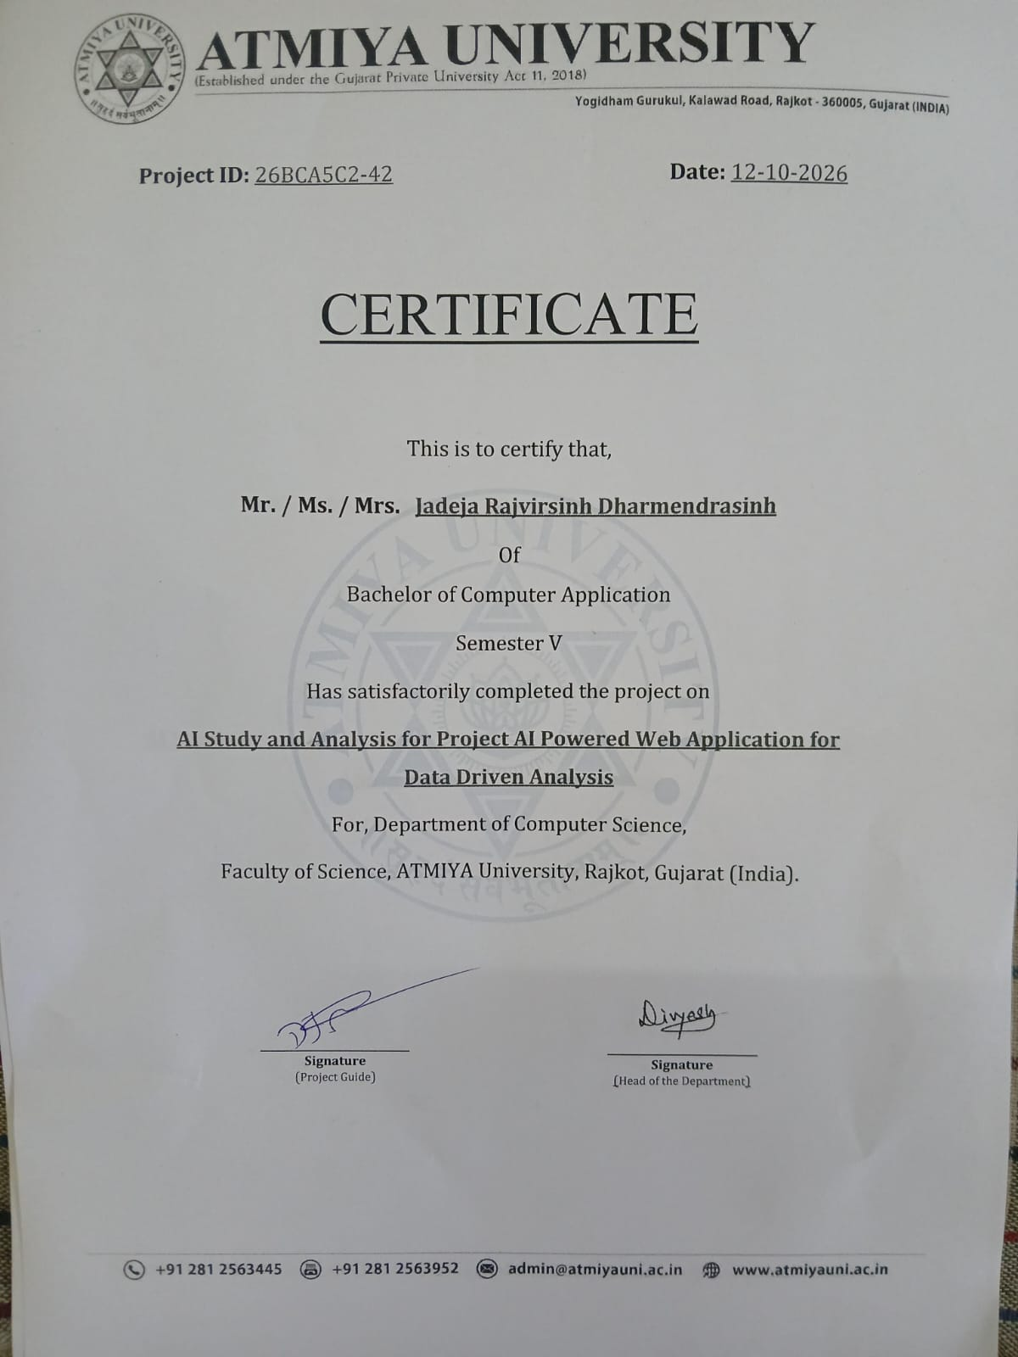

DECLARATION

I hereby declare that the project report titled “AI Study Assistant” is my original work and has been completed under the guidance of Mrs. Dharmishtha Makwana. This project is submitted in the partial fulfillment of the requirements for the award of the Degree of B.Sc. Information Technology, Semester – V (2026–27) under the Faculty of Science, Department of Computer Science, Atmiya University, Rajkot, Gujarat-India.

I also declare that this work has not been submitted to any other university or institution for any degree, diploma, or certificate.

Name of Student: Jadeja Rajvirsinh D.
Enrollment No.: 240801249
Signature: Date: 22/08/2026

ACKNOWLEDGEMENT

I express my deep sense of gratitude to the following respected authorities of Atmiya University for their constant support, guidance, and encouragement throughout the completion of this project.
I am sincerely thankful to P. P. Tyagvallabh Swami (President, Atmiya University) for providing an excellent educational environment and continuous encouragement toward academic excellence.
I extend my gratitude to Dr. D. D. Vyas (Registrar, Atmiya University) for ensuring smooth academic processes and administrative support that contributed to the successful completion of this project.
I am grateful to Er. R. S. Tank (Dean, Faculty of Science) for his valuable support, motivation, and guidance throughout the duration of the program.
My heartfelt thanks to Dr. D. P. Gohel (Head, Department of Computer Science) for providing necessary facilities, timely support, and continuous encouragement during the project work.
I would like to express my special appreciation and sincere thanks to my project guide Mrs. Dharmishtha Makwana, whose expert guidance, patience, and valuable suggestions helped me complete this project successfully.

I am also thankful to all the faculty members of the Department of Computer Science for their support, feedback, and academic insights throughout the course.
Finally, I gratefully acknowledge the constant support, motivation, and encouragement of my family and friends, without which this project would not have been completed.

ABSTRACT

AI Study Assistant is a web-based learning platform designed to help students study more effectively using Artificial Intelligence. The system allows users to register, upload PDF study materials, ask questions based on the uploaded content, generate practice quizzes, manage personal study materials, and track learning progress through a dashboard.
The application is developed using the Flask framework in Python. PDF text extraction is performed using PyMuPDF (fitz). Artificial Intelligence features such as question answering and automatic quiz generation are implemented using the Google Gemini API. User data, uploaded PDFs, chat history, quiz results, study materials, and progress statistics are stored in an SQLite database. Role-based access is provided for students and administrators.
The main objective of this project is to reduce the time students spend searching for information inside large PDF documents, provide instant AI-based explanations from study material, and offer automated quiz practice for self-assessment. The system also includes an admin panel for managing users, PDFs, quizzes, study materials, and contact messages.
Overall, AI Study Assistant provides a practical and integrated digital solution for PDF-based learning, AI-assisted doubt solving, and quiz-based revision, making the study process more organized and efficient for students.

TABLE OF CONTENTS

SN | Chapter | Page No.
 | Certificate | I
 | Declaration | II
 | Acknowledgement | III
 | Abstract | IV
 | Table of Contents | V
1 | Introduction | 1
2 | Problem Definition | 4
3 | Objectives of the Study | 5
4 | System Analysis | 6
5 | System Design | 9
 | 5.1 System Architecture
 | 5.2 Data Flow Diagrams (DFD)
 | 5.3 Use Case Diagram
 | 5.4 Class Diagram
 | 5.5 Activity Diagram
 | 5.6 ER Diagram
 | 5.7 Database Design
6 | Implementation | 19
7 | Testing | 23
8 | Output Screenshots | 25
9 | Conclusion | 32
10 | Future Scope | 33
11 | Bibliography / References | 34
12 | Appendix | 35

INTRODUCTION

OVERVIEW OF THE PROJECT
AI Study Assistant is a web-based application developed to support students in their academic learning process. The system integrates PDF study material management, Artificial Intelligence based question answering, automatic quiz generation, progress tracking, and administrative control into a single platform.
Students can create an account, upload their PDF notes or textbooks, ask questions related to the content of those PDFs, and receive AI-generated answers grounded in the uploaded material. The system can also generate multiple-choice quizzes from the PDF content so that students can practice and evaluate their understanding. A personal dashboard displays statistics such as number of uploaded PDFs, quizzes attempted, and AI chats performed.
An administrator module allows authorized staff to view and manage registered users, uploaded PDFs, quiz records, study materials, and contact messages submitted through the website.

PURPOSE AND SCOPE
The purpose of this project is to design and develop a practical learning assistant that reduces manual effort in studying from PDF documents and provides AI-supported learning tools.
The scope of the project includes:

- User registration and secure login
- PDF upload and storage linked to the logged-in user
- AI-powered question answering based on selected PDF content
- Automatic generation of multiple-choice quizzes from PDF text
- Quiz evaluation and score storage
- Study material management and online Wikipedia search support
- User progress dashboard
- Admin panel for system monitoring and data management
- Contact form for user feedback

The system is intended primarily for students who study from digital PDF materials and need quick AI assistance and practice quizzes.

BACKGROUND INFORMATION
In recent years, students have increasingly relied on digital notes, e-books, and PDF documents for learning. While PDFs are convenient to store and share, finding specific information inside long documents is time-consuming. Traditional methods of preparing questions for self-assessment also require significant manual effort.
Artificial Intelligence models, especially large language models accessible through APIs such as Google Gemini, now make it possible to process document text and generate answers or questions automatically. Combining PDF processing libraries with such AI services creates an opportunity to build practical study tools. This project uses that opportunity to create an integrated AI Study Assistant for students.

TARGET USERS
The primary users of the system are students who want to study from PDF materials with AI support. Secondary users are administrators who manage the platform, view usage statistics, and handle contact messages.

REAL-WORLD RELEVANCE
Students in colleges and universities frequently prepare from PDF notes and textbooks. An application that can answer questions from their own study material and generate quizzes on demand can improve revision efficiency and reduce dependence on manual note searching. The project therefore addresses a genuine academic need using currently available web and AI technologies.

PROBLEM DEFINITION

Students face several difficulties while preparing for examinations and completing assignments using traditional and semi-digital methods.

PROBLEMS WITH TRADITIONAL STUDY METHODS
Printed notes and long PDF files make it hard to locate a particular topic quickly. Students often spend considerable time scrolling through documents instead of focusing on understanding concepts.

DIFFICULTY IN GETTING QUICK ANSWERS FROM STUDY MATERIAL
When a student has a doubt related to a specific paragraph or chapter in a PDF, there is usually no immediate way to ask a question and receive an answer grounded in that same material. General search engines may return unrelated information.

LACK OF AUTOMATED QUIZ PRACTICE
Creating good multiple-choice questions from study material requires time and subject knowledge. Many students do not prepare enough practice questions and therefore have limited self-assessment opportunities before exams.

MANAGEMENT OF STUDY MATERIALS
Students may keep PDFs, notes, and reference files in different folders without a central system linked to their learning activities. Tracking how many documents were studied or how many quizzes were attempted is usually done manually or not at all.

NEED FOR AN INTEGRATED AI-BASED PLATFORM
There is a clear need for a single web application where a student can upload PDFs, ask questions about the content, generate quizzes automatically, save additional study materials, and view progress statistics. AI Study Assistant is designed to address these problems by combining PDF processing, Gemini-based AI services, and a structured database-backed user interface.

OBJECTIVES OF THE STUDY

The main objectives of this project, based on the implemented system, are as follows:

- To develop a web-based AI Study Assistant using Flask that supports student registration, login, and secure session management.
- To enable users to upload PDF study materials and store them in association with their user account.
- To extract text from uploaded PDFs using PyMuPDF and use that text as context for Artificial Intelligence responses.
- To integrate the Google Gemini API so that students can ask questions and receive answers based on the selected PDF content.
- To generate multiple-choice quizzes automatically from PDF content and allow students to attempt and evaluate them.
- To store chat history and quiz results for later review by the user.
- To provide a study materials module for saving additional files and searching online (Wikipedia) references.
- To display a student dashboard with progress indicators such as total PDFs, quizzes, and AI chats.
- To implement an administrator panel for managing users, PDFs, quizzes, study materials, and contact messages.
- To maintain data integrity and basic security through password hashing and role-based access control.

SYSTEM ANALYSIS

EXISTING SYSTEM
In the existing approach, students typically keep PDF notes on their local devices or cloud drives. To clarify doubts they either search the web, ask teachers or peers, or re-read the entire document. Practice questions are either taken from previous papers or prepared manually. There is usually no integrated system that links a student’s own PDFs with AI question answering, automatic quiz generation, and progress tracking in one place.
Manual searching inside large PDFs is slow. Answers from general search engines may not match the exact syllabus or wording of the student’s notes. Tracking learning activity remains informal.

PROPOSED SYSTEM
The proposed AI Study Assistant provides a centralized web platform where each registered student can:
- Upload and manage personal PDF files
- Select a PDF and ask questions; the system extracts text and sends a contextual prompt to the Gemini model
- Generate quizzes from PDF content and attempt them online
- Save extra study materials and search Wikipedia for related topics
- View personal progress on a dashboard
- Contact the system administrators through a contact form

Administrators can log in separately, view overall statistics, and manage users and content.

FEASIBILITY STUDY

Technical Feasibility
The project uses mature and freely available technologies: Python, Flask, SQLite, PyMuPDF, and the Google Gemini API. These tools are well documented and run on standard development machines. Therefore the system is technically feasible.

Economic Feasibility
Most components (Python, Flask, SQLite, PyMuPDF) are open source. Gemini API usage may involve usage-based costs depending on the plan, but for academic and moderate student use the cost remains reasonable. No expensive proprietary software is required for basic deployment. Hence the project is economically feasible for an academic setting.

Operational Feasibility
The interface is browser-based. Students only need a web browser and internet connectivity (for AI features). Admin operations are also web-based. Training requirements are minimal. Operational feasibility is therefore high.

REQUIREMENT SPECIFICATION

Hardware Requirements
Minimum recommended configuration for development and local deployment:

Component | Minimum Requirement
Processor | Dual-core CPU or higher
RAM | 4 GB (8 GB recommended)
Storage | 500 MB free space for application and uploads
Display | Standard monitor with browser support
Network | Internet connection for Gemini API and email features

Software Requirements
Based on the actual project implementation, the following software components are used:

Software / Library | Purpose
Python 3.x | Programming language
Flask | Web framework and routing
SQLite | Relational database (study.db)
Werkzeug | Password hashing and secure filename handling
PyMuPDF (fitz) | PDF text extraction
google-genai | Google Gemini API client for AI Q&A and quiz generation
python-dotenv | Loading environment variables (API key)
HTML, CSS, JavaScript | Front-end templates and interactivity
smtplib / email | Sending welcome and login notification emails

SYSTEM DESIGN

SYSTEM ARCHITECTURE
The application follows a layered web architecture:

User (Browser) → Flask Application (Blueprints: home, auth, dashboard, upload, chat, quiz, materials, admin) → Business Logic & Utilities (PDF reader, Gemini client) → Data Layer (SQLite database) and External Services (Gemini API, SMTP, Wikipedia API).
Request flow:

- The user interacts through HTML templates rendered by Flask.
- Routes under different blueprints handle authentication, uploads, chat, quiz, materials, and admin operations.
- PDF text is extracted by the utils.pdf_reader module using PyMuPDF.
- AI prompts are sent to the Gemini model via the google.genai client.
- Persistent data is stored in SQLite tables managed by database/db.py.

DATA FLOW DIAGRAMS

Context Level (Level 0) DFD

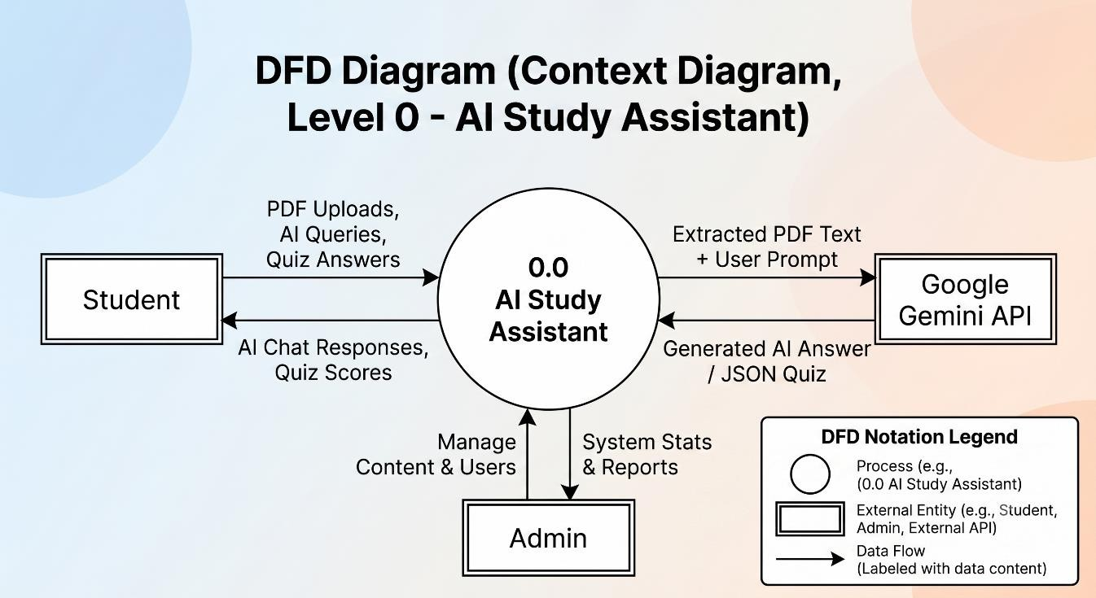

Level 1 DFD

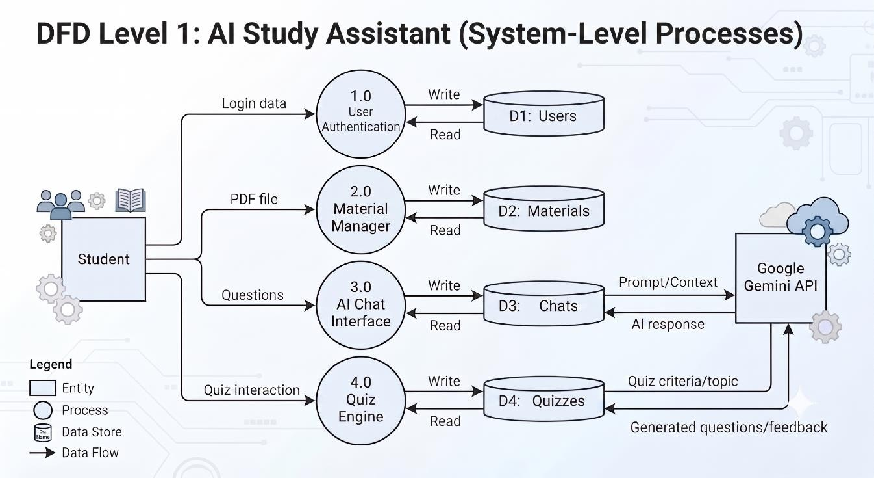

Level 2 DFD
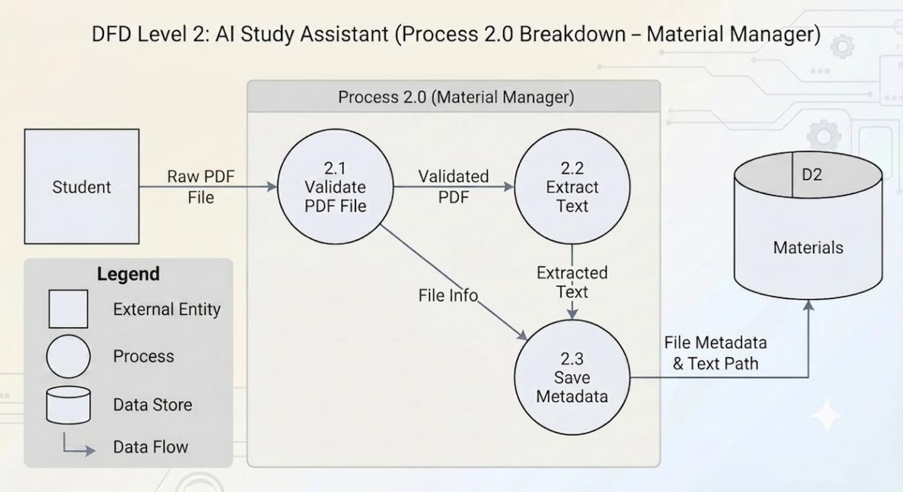

USE CASE DIAGRAM
Actors identified from the implementation:

- Student (registered user)
- Administrator
- External Gemini API (system dependency)
Student use cases: Register, Login, Logout, Upload PDF, Ask AI Question, Generate Quiz, Attempt Quiz, View Quiz History, Manage Study Materials, View Dashboard, Submit Contact Message.
Administrator use cases: Admin Login, View Dashboard Statistics, Manage Users, Manage PDFs, Manage Quizzes, Manage Study Materials, View/Delete Contact Messages, Admin Logout.

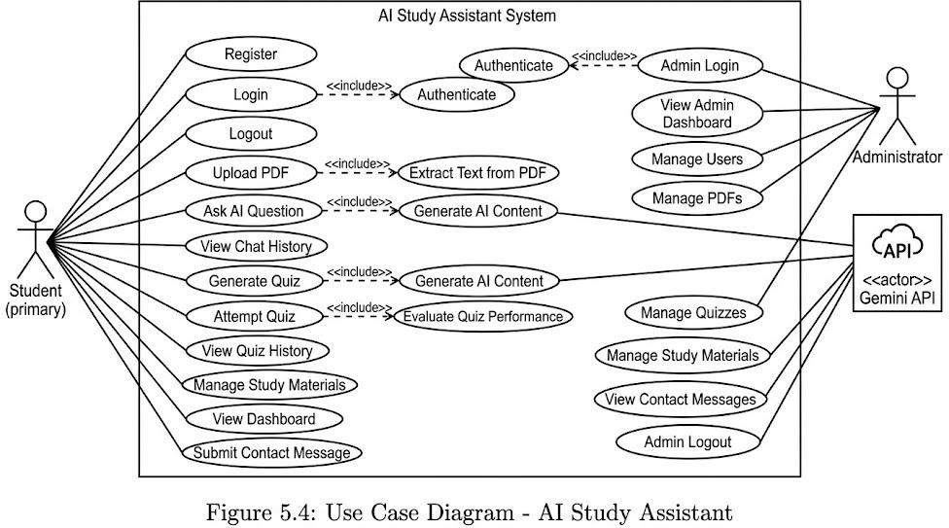

CLASS DIAGRAM
The project is primarily modular and route-based rather than heavily object-oriented. Important logical components that can be represented are:
- Flask Application (app.py) – registers blueprints and creates database
- Database Module (db.py) – connection and schema creation
- Auth Blueprint – register, login, logout, email notifications
- Upload Blueprint – PDF upload and storage
- Chat Blueprint – PDF selection, text extraction, Gemini Q&A, history
- Quiz Blueprint – quiz generation via Gemini, evaluation, history
- Materials Blueprint – study material CRUD and Wikipedia search
- Dashboard Blueprint – progress statistics
- Admin Blueprint – admin authentication and management screens
- PDF Reader Utility – extract_text(pdf_path)

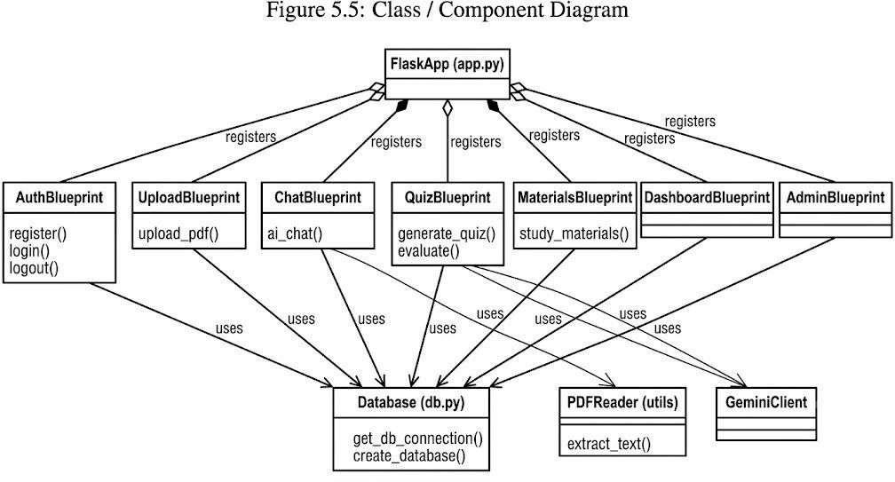

ACTIVITY DIAGRAM
Typical student workflow:

Start → Register / Login → Dashboard → (Upload PDF | Open AI Chat | Open Quiz | Open Materials) → For Chat: Select PDF → Enter Question → Extract Text → Call Gemini → Show Answer → Save History → For Quiz: Select PDF → Generate Questions → Attempt
→ Evaluate Score → Save Result → Logout.

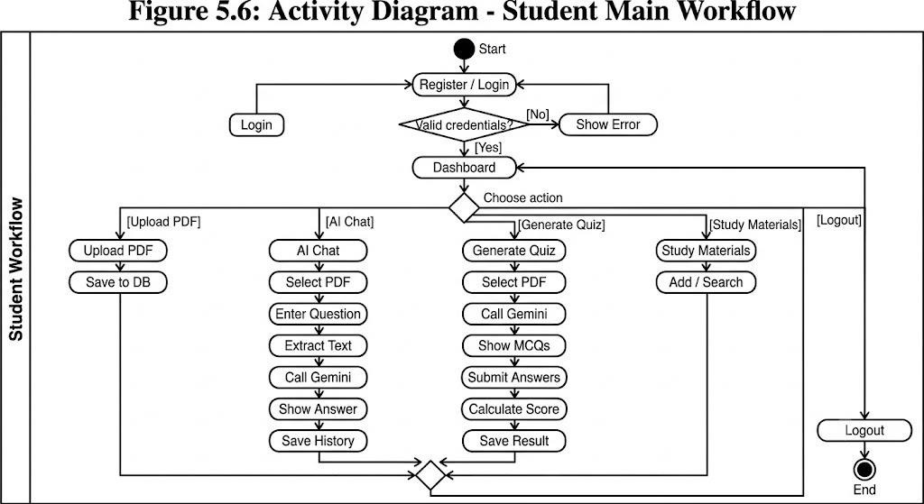

ER DIAGRAM
Entities and relationships derived from the actual SQLite schema: users (1) — (N) pdfs
users (1) — (N) chat_history users (1) — (N) quizzes
users (1) — (N) study_materials users (1) — (0..1) progress
pdfs (1) — (0..N) study_materials (via source_pdf_id) admins is independent for administrative login.
contact_messages is independent for contact form submissions.

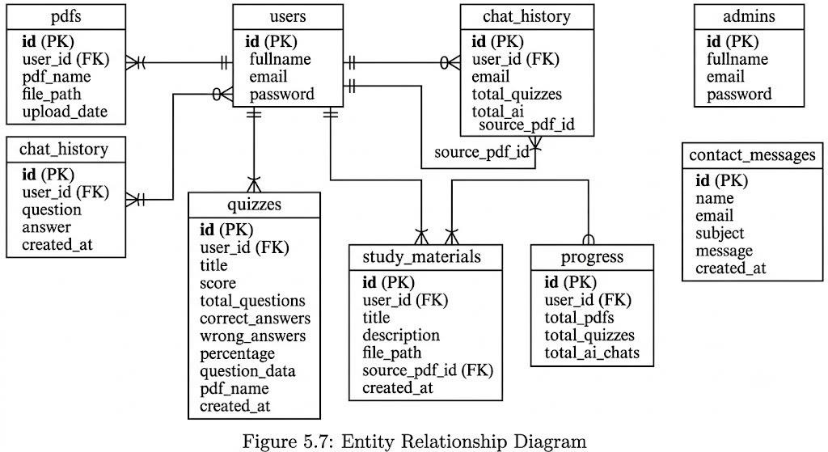

DATABASE DESIGN
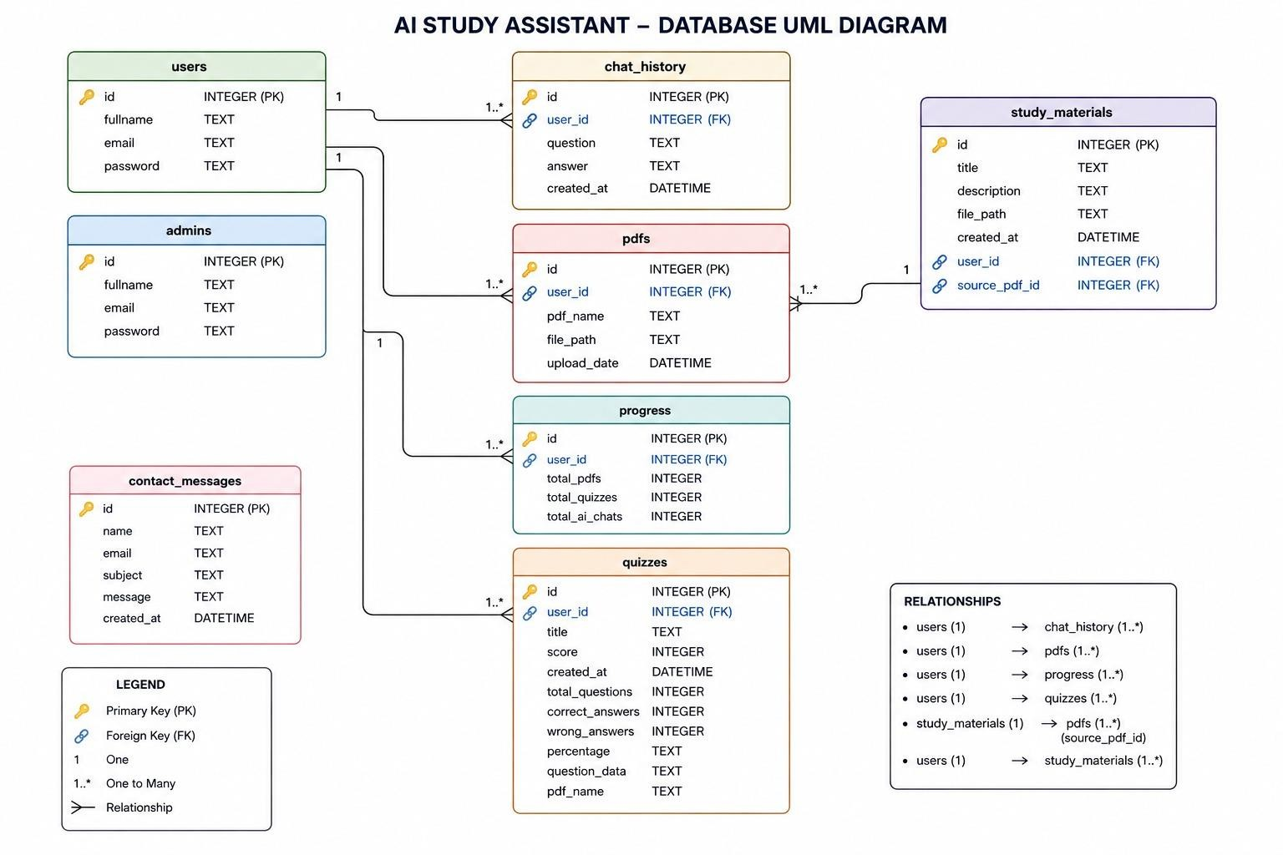

DATABASE DESIGN
The database file is database/study.db. Tables and important fields are:

Table Name | Purpose | Important Fields
users | Registered students | id, fullname, email, password
pdfs | Uploaded PDF files | id, user_id, pdf_name, file_path, upload_date
chat_history | AI Q&A history | id, user_id, question, answer, created_at
quizzes | Quiz attempts & results | id, user_id, title, score, total_questions, correct_answers, wrong_answers, percentage, question_data, pdf_name, created_at
study_materials | Saved study materials | id, user_id, title, description, file_path, source_pdf_id, created_at
progress | User activity counters | id, user_id, total_pdfs, total_quizzes, total_ai_chats
admins | Administrator accounts | id, fullname, email, password
contact_messages | Contact form messages | id, name, email, subject, message, created_at

IMPLEMENTATION

MODULE DESCRIPTION

User Module : Manages User and show Admin Dashboard
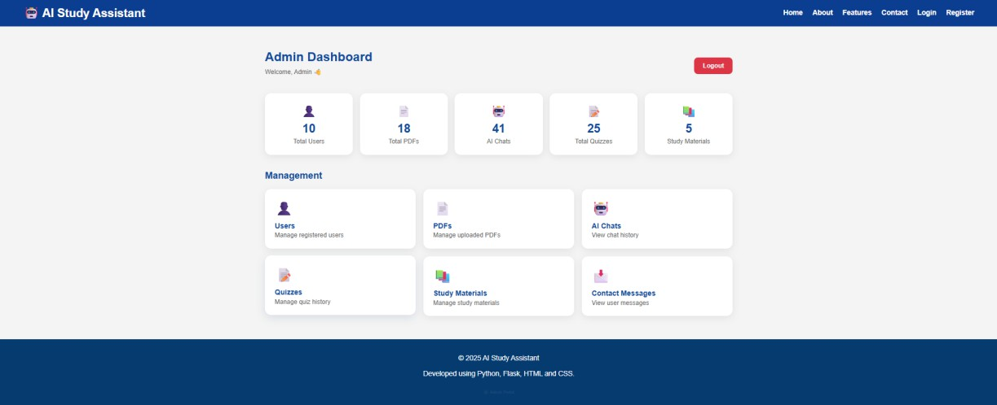

User Module : Manage Register Users
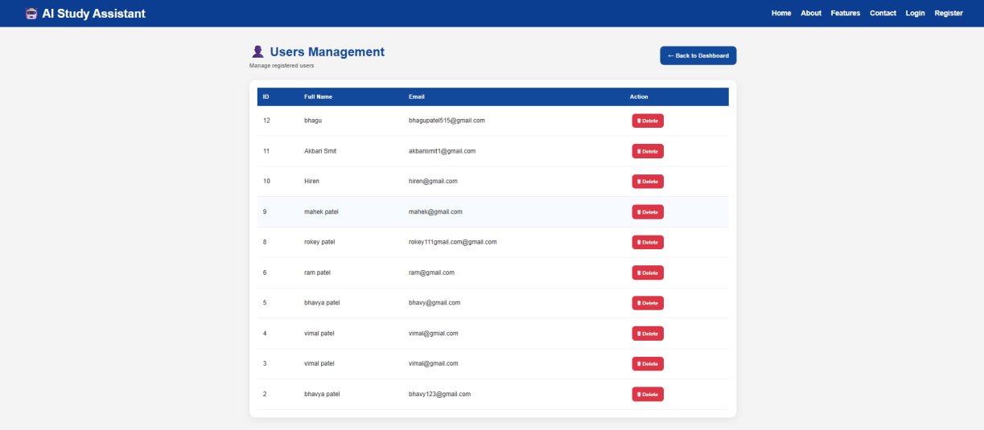

PDFs Module : Manage Uploaded PDFs
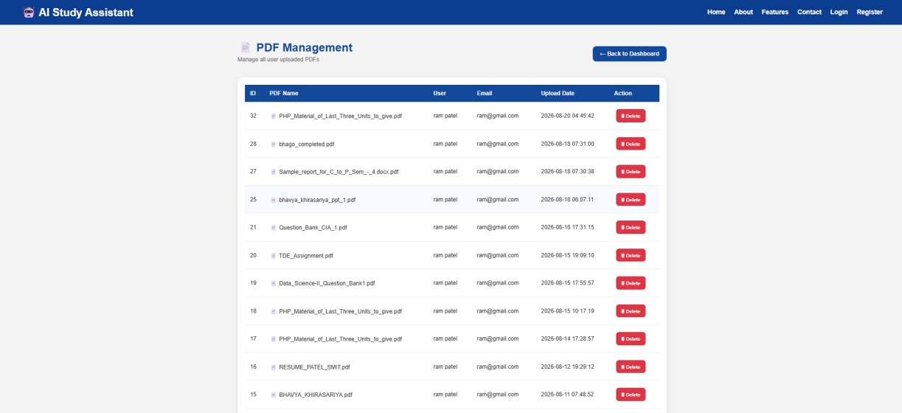

AI Chats Module : View Chat History
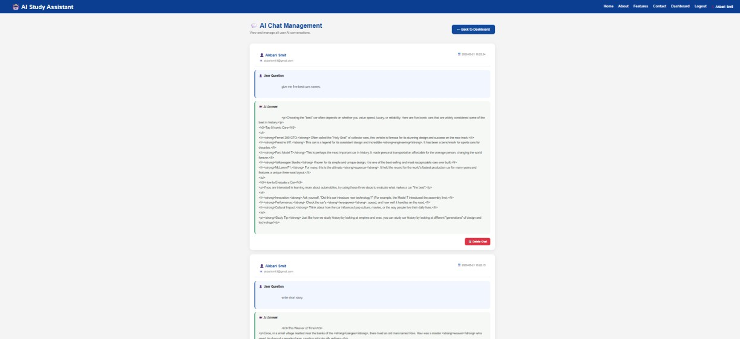

Quizzes Module : Manage Quiz History
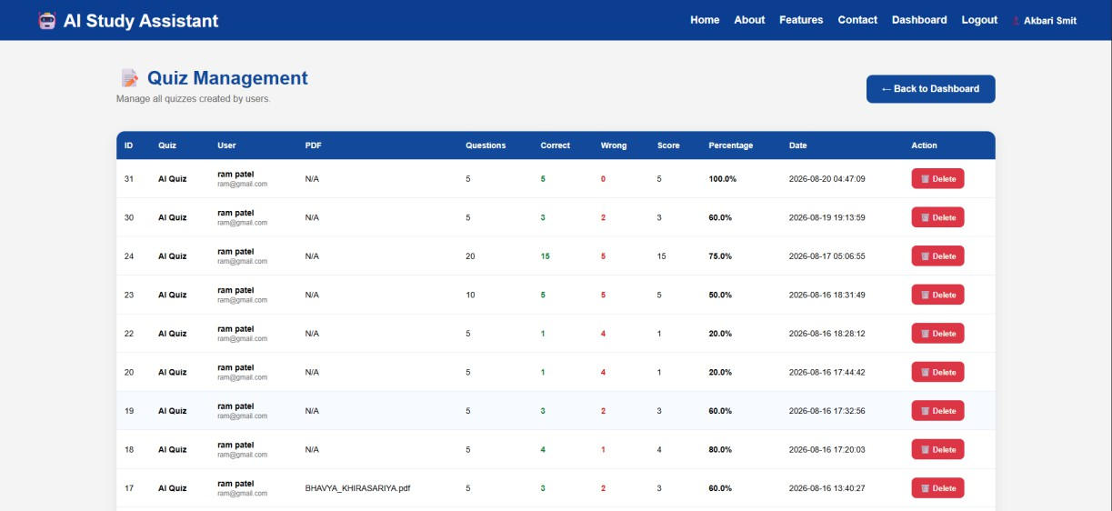

Study Materials : Manage Study Materials
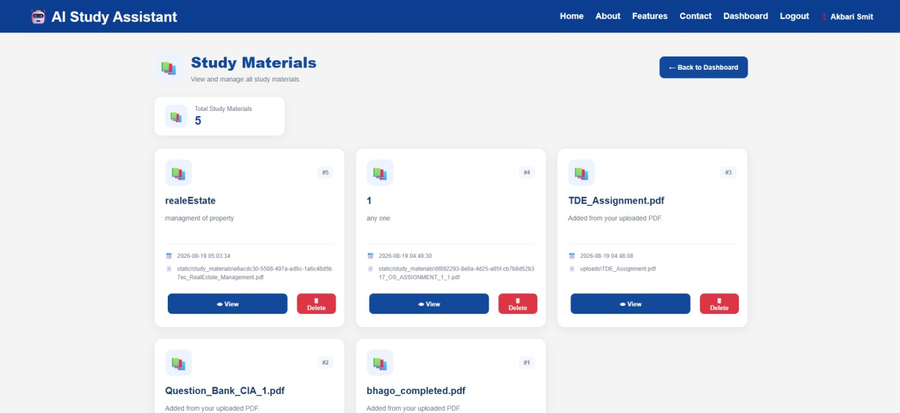

Contact Messages : View User Messages
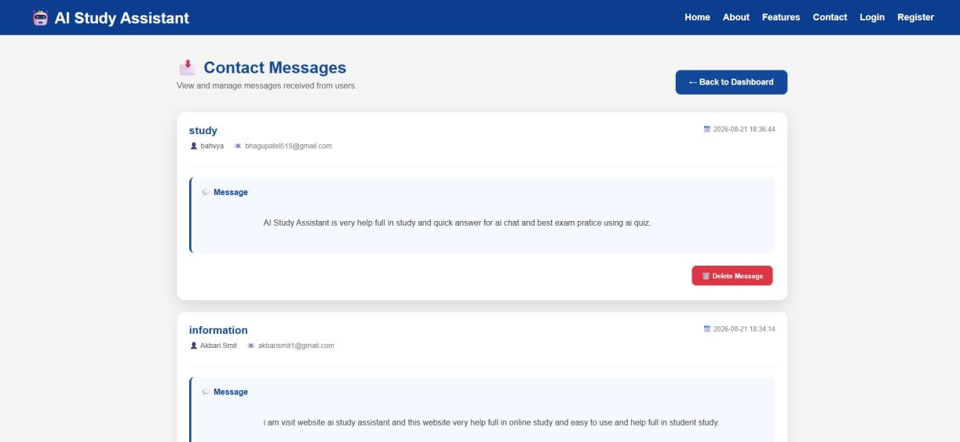

TECHNOLOGY STACK
Backend: Python with Flask blueprints. Database: SQLite via the sqlite3 module. PDF processing: PyMuPDF (import fitz). AI: Google Gemini through the google.genai client (model used in code: gemini-3.1-flash-lite). Security: Werkzeug password hashing. Front-end: Jinja2 templates with HTML, CSS, and JavaScript. Configuration: environment variables loaded with python-dotenv for the Gemini API key.

PROJECT ARCHITECTURE
The main application file (app.py) creates the Flask app, sets a secret key for sessions, calls create_database(), and registers blueprints: home, auth, dashboard, chat, upload, admin, materials, and quiz. Supporting modules live under routes/, database/, utils/, templates/, static/, and uploads/.

TESTING

TESTING APPROACH
Testing was performed manually by exercising the main user and admin workflows through the web interface. Each feature was checked for correct behaviour with valid and invalid inputs. Database records were inspected to confirm that inserts and updates occurred as expected. AI features were tested with sample PDFs to verify that answers and quizzes were generated from the document content.

TYPES OF TESTING
- Functional Testing – verifying registration, login, upload, chat, quiz, materials, and admin features
- Integration Testing – checking interaction between Flask routes, database, PDF extractor, and Gemini API
- User Interface Testing – ensuring pages render and forms submit correctly
- Validation Testing – rejecting empty fields, non-PDF uploads, and unauthorized access
- Authentication Testing – session checks for student and admin areas
- Database Testing – verifying records in users, pdfs, chat_history, quizzes, and related tables

TEST CASES

ID | Module | Scenario | Input | Expected | Actual | Status
TC01 | Auth | Valid registration | New name, email, password | Account created, redirect/login | As expected | Pass
TC02 | Auth | Duplicate email | Existing email | Error / rejection | As expected | Pass
TC03 | Auth | Valid login | Correct credentials | Session created, dashboard | As expected | Pass
TC04 | Auth | Invalid login | Wrong password | Error message | As expected | Pass
TC05 | Upload | Valid PDF upload | Valid .pdf file | Saved and listed | As expected | Pass
TC06 | Upload | Non-PDF file | Image/other file | Rejected with message | As expected | Pass
TC07 | Chat | Question with PDF | Selected PDF + question | AI answer displayed | As expected | Pass
TC08 | Chat | Empty question | Blank question | Validation message | As expected | Pass
TC09 | Quiz | Generate quiz | Selected PDF | JSON questions shown | As expected | Pass
TC10 | Quiz | Submit answers | Selected options | Score calculated & saved | As expected | Pass
TC11 | Materials | Add material | Title + allowed file | Material saved | As expected | Pass
TC12 | Dashboard | View progress | Logged-in user | Counts displayed | As expected | Pass
TC13 | Admin | Admin login | Valid admin credentials | Admin dashboard | As expected | Pass
TC14 | Auth | Logout | Click logout | Session cleared | As expected | Pass
TC15 | Access | Protected page without login | Direct URL | Redirect to login | As expected | Pass

OUTPUT SCREENSHOTS

The following placeholders indicate where actual application screenshots should be inserted. Replace each placeholder with a clear screenshot from the running system and keep the figure captions.

Figure 8.1: Home / Landing Page
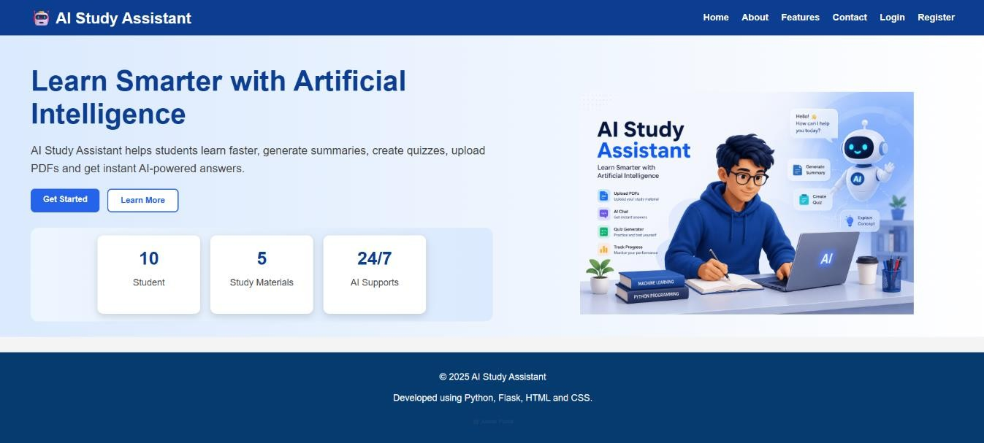
Shows the public landing page of AI Study Assistant.

Figure 8.1: About Page
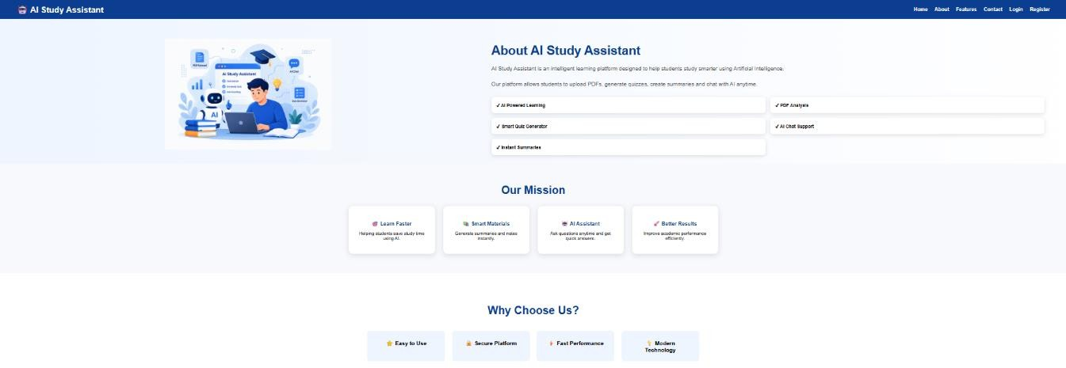

Dedicated page explaining the purpose, benefits, and team behind the AI Study Assistant.

Figure 8.1: Features Page
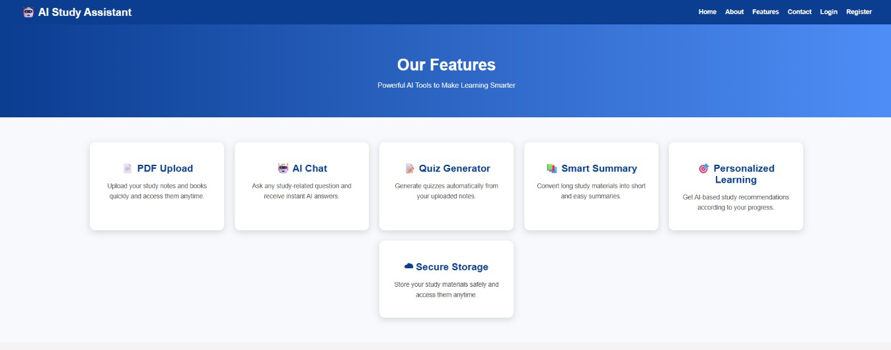

Overview of platform capabilities featuring PDF upload, interactive AI chat, automated quiz generation, and smart summaries.

Figure 8.1: Contact Page
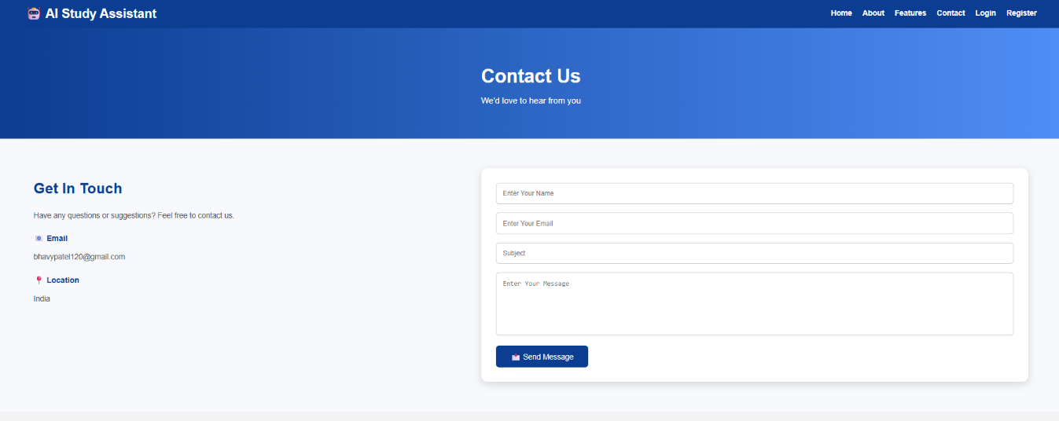

Dedicated page featuring inquiry forms and contact details for user support and communication.

Figure 8.2: User Registration Page
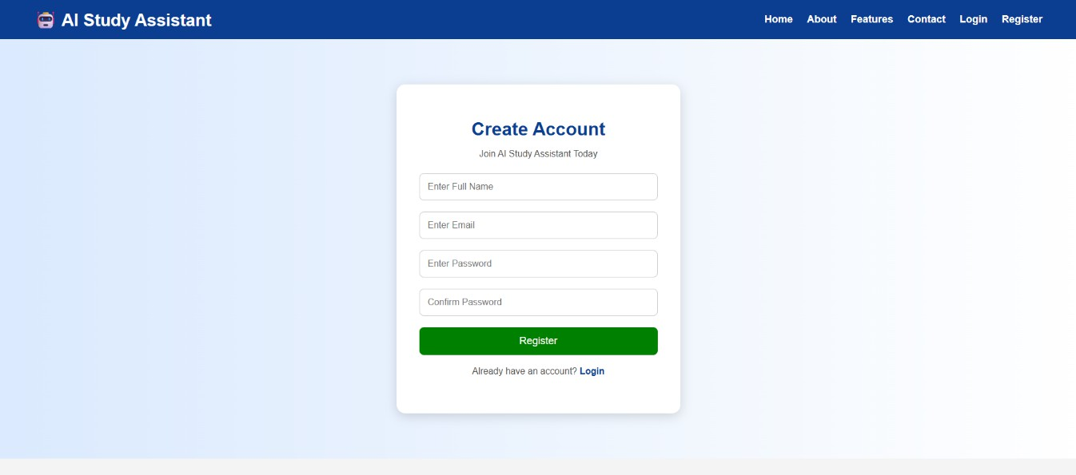

Registration form for new students.

Figure 8.3: User Login Page
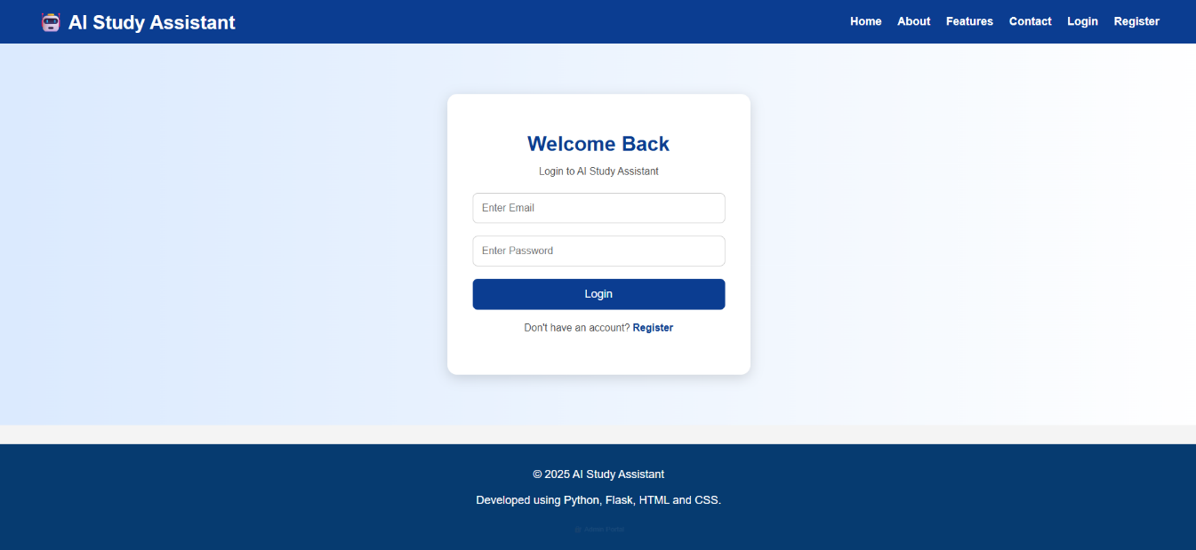

Login form for registered students.

Figure 8.4: Student Dashboard
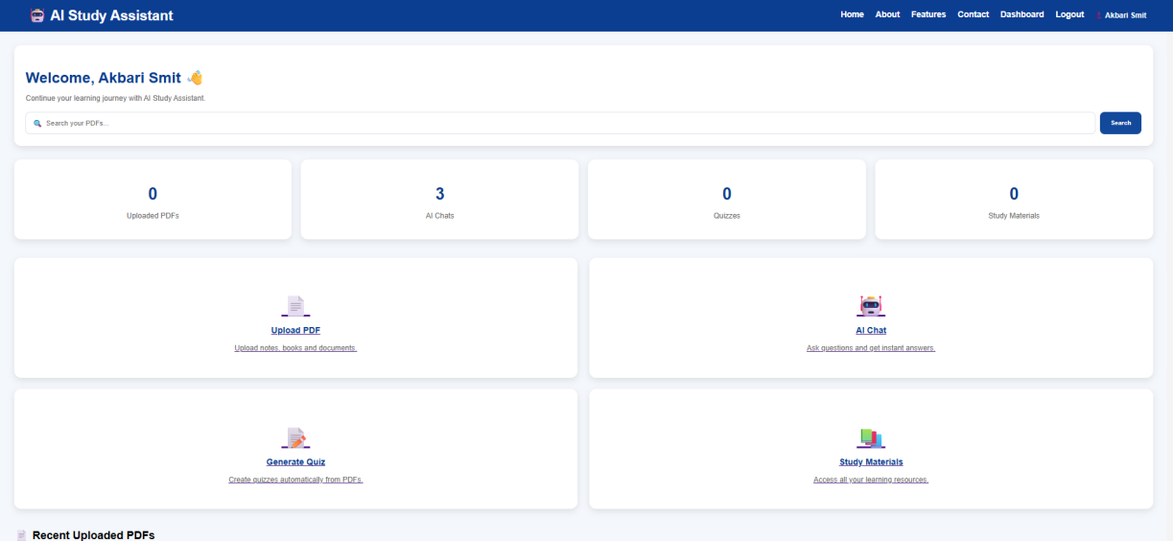

Dashboard showing progress statistics such as PDFs, quizzes, and AI chats.

Figure 8.5: PDF Upload Page
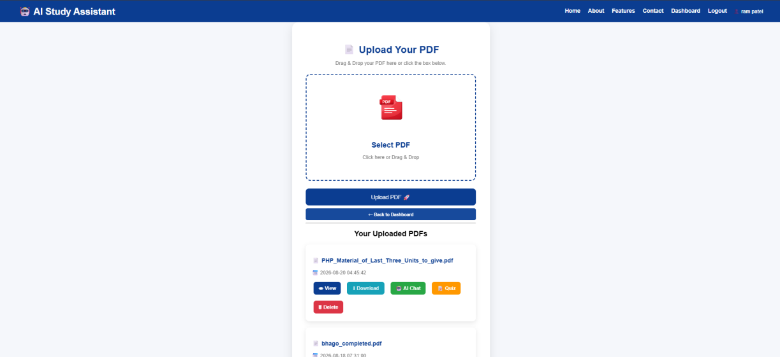

Interface for selecting and uploading a PDF file.

Figure 8.6: AI Chat Interface
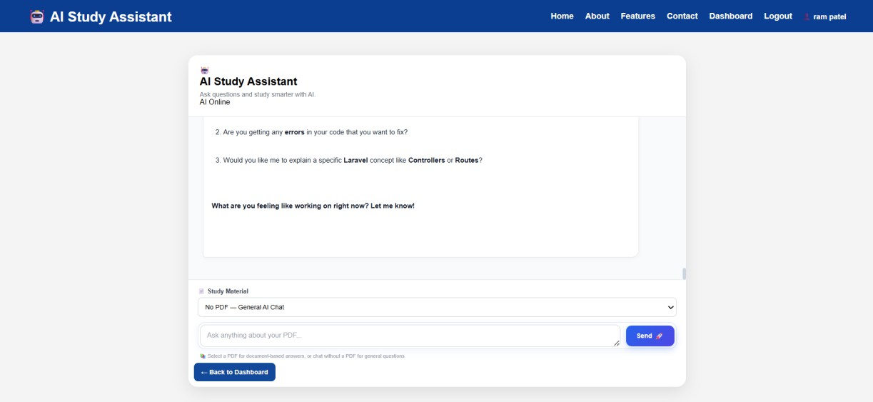

Page where the user selects a PDF and asks questions.

Figure 8.7: Quiz Generation / Attempt
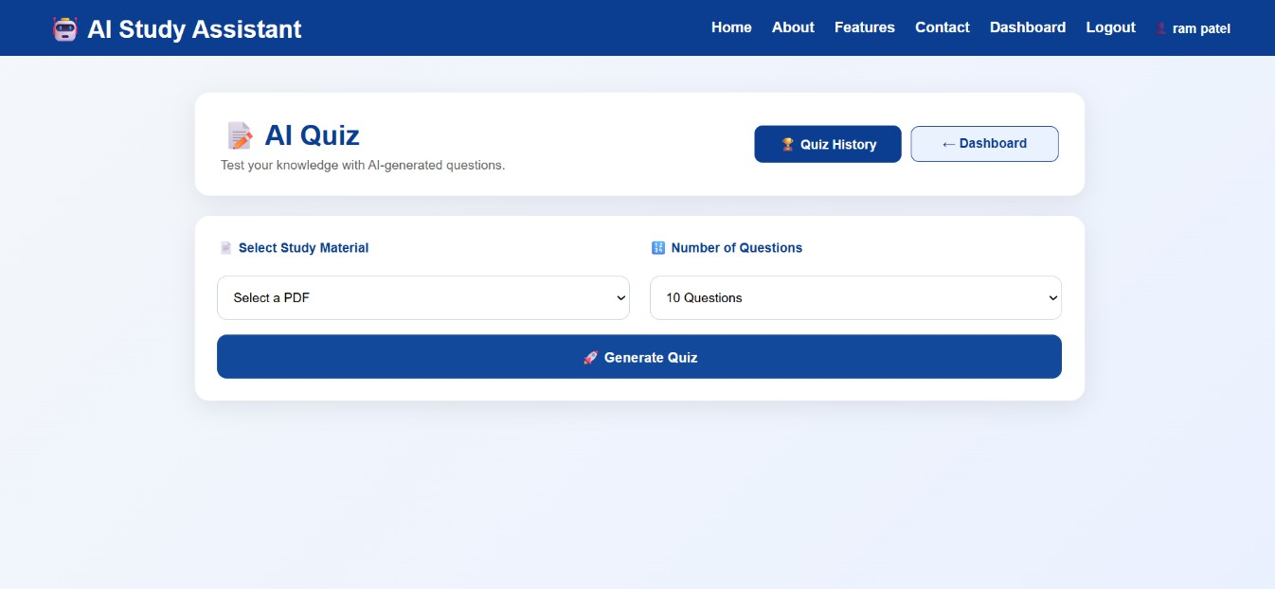

Quiz interface with generated multiple-choice questions.

Figure 8.8: Quiz Result / History
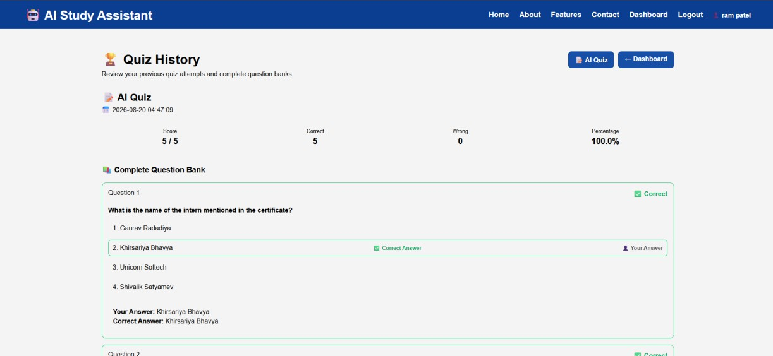

Display of score and previous quiz attempts.

Figure 8.9: Study Materials Page
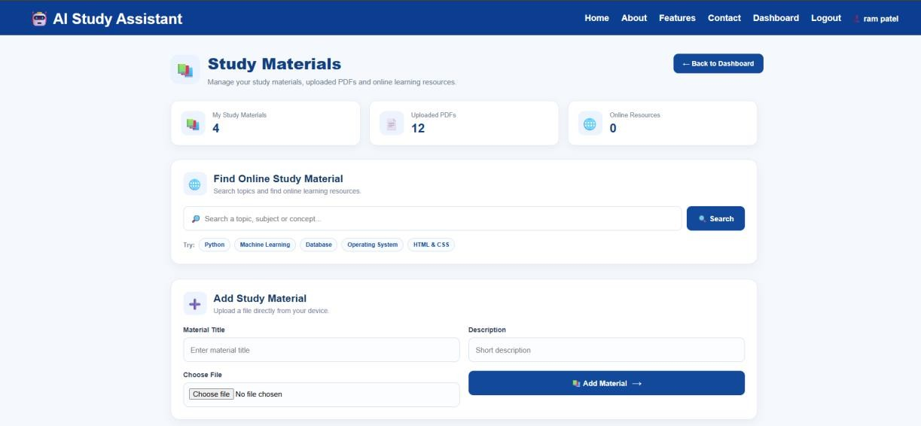

Study materials list and online search results.

Figure 8.10: Admin Dashboard
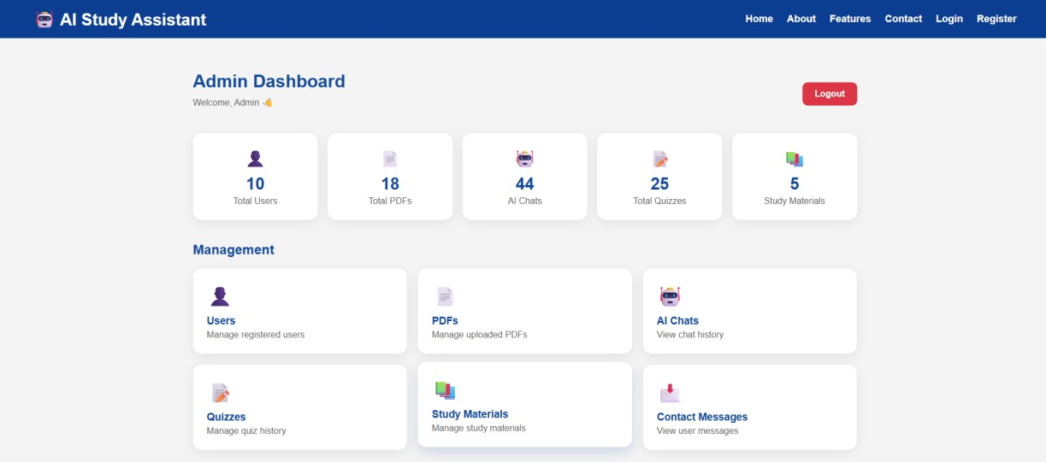

Administrator overview of system data.

CONCLUSION

The AI Study Assistant project successfully implements a web-based platform that helps students learn from PDF materials with the support of Artificial Intelligence. The system allows registration and login, PDF upload, AI-powered question answering grounded in document text, automatic multiple-choice quiz generation and evaluation, study material management, progress tracking, and administrative oversight.
By combining Flask, SQLite, PyMuPDF, and the Google Gemini API, the project demonstrates a practical approach to modern digital learning tools. It reduces the time spent searching inside long documents, provides instant contextual answers, and offers automated practice quizzes for self-assessment.
The objectives defined for the project have been met within the implemented scope. The application is suitable for academic demonstration and can serve as a foundation for further enhancements in personalized learning systems.

FUTURE SCOPE

Possible future enhancements that are not part of the current implementation include:

- Support for additional document formats beyond PDF for AI context.
- Improved personalization of AI answers based on user history and difficulty level.
- Voice-based question input and spoken answers.
- Native mobile application or progressive web app.
- Advanced analytics and learning recommendations.
- Multi-language support for questions and answers.
- Cloud deployment with scalable storage and stronger security hardening.
- Collaborative study groups and shared materials.
- More detailed quiz analytics and spaced-repetition features.

BIBLIOGRAPHY / REFERENCES

- Flask Documentation. https://flask.palletsprojects.com/
- Python Software Foundation. Python Documentation. https://docs.python.org/3/
- SQLite Documentation. https://www.sqlite.org/docs.html
- PyMuPDF Documentation. https://pymupdf.readthedocs.io/
- Google AI / Gemini API Documentation. https://ai.google.dev/
- Werkzeug Security Documentation. https://werkzeug.palletsprojects.com/
- python-dotenv. https://pypi.org/project/python-dotenv/
- MDN Web Docs – HTML, CSS, JavaScript. https://developer.mozilla.org/
- Atmiya University – Project Report Guidelines (supplied General Guidelines Project Report).

APPENDIX

PROJECT STRUCTURE (ACTUAL)
AI_Study_Assistant_project/

├── app.py

├── create_admin.py

├── database/

│ ├── db.py

│ └── study.db

├── routes/

│ ├── auth.py

│ ├── home.py

│ ├── dashboard.py

│ ├── upload.py

│ ├── chat.py

│ ├── quiz.py

│ ├── materials.py

│ └── admin/admin.py

├── utils/

│ └── pdf_reader.py

├── templates/ (HTML pages for user and admin)

├── static/

├── uploads/

└── .env (contains API key – not to be shared)

IMPORTANT CONFIGURATION NOTES
- Application secret key is set in app.py for session management.

- Gemini API key must be provided via environment variable gemini_api_key.

- Admin account can be created using create_admin.py (do not commit real passwords).

- Sensitive credentials (API keys, email app passwords) must never be published in the report or public repositories.

SELECTED IMPLEMENTATION NOTES
PDF text extraction is performed by opening the file with fitz.open and concatenating page.get_text() results. AI prompts for chat include the PDF name and truncated text. Quiz prompts request strict JSON output with four options per question. Session checks protect student and admin routes. Password hashing uses Werkzeug’s generate_password_hash and check_password_hash.

LIMITATIONS OBSERVED IN IMPLEMENTATION
- AI quality depends on the Gemini model and the completeness of extracted PDF text.

- Very large PDFs are truncated before being sent to the model.

- Email features require valid SMTP credentials.

- The system is designed primarily for single-server / local or small-scale deployment.

- Automated unit test suite is not part of the current codebase; testing was performed manually.

